**Interview Questions:-**

**JAVA:-**

It is High Level Object Oriented Programming Language.

**Programming**: Step by Step procedure combined together to perform a specific task.

Programming Language is done by processor

**Class**: It is a blue print which defines properties(variables) and behaviour(method).

**Object :**is an instance of class which has properties(variables) and behaviour(method).

**Data Types**: Which defines specific type of data

**Types of Data Types:**

**1)Primitive Data Type.**

It is predefined in java, specific fixed size, they are keywords, lower case

Ex:int,char……..

**2)Non-Primitive Data Type.**

They are reference type, becuz they refer objects. Created by programmer

ex:Strings, Arrays, System, Classes.

**Variables:**

Variable is used to store data.

**Four types:**

1)Local Variable.

2)Static

3)Instance

4)Parameter

**1)Local Variable:**

it is a variable defined inside class , constructor and main method.

**2)Static:**

It is variable defined inside class and outside main method with static keyword.

**3)Instance:**

If static is not defined, then instance variable and it is defined outside main method

**4)Parameter:**

It is variable declared with method signature (used to pass data).

**5)Array:**

It is a container which stores similar type of data into single variable.

**6)String :** String is a class

It is used to store sequence of characters, non-primitive type.

**7)Method:**

Method is a block of code which perform specific functionality

**OOPS concepts**

**1)Abstraction:** It is a process of hiding implementation and showing only functionality.

Types of coupling:

Loose coupling:Change in implementation which will not affect user

Type Coupling:Change in implementation which will affect user

**1)Encapsulation:**

Binding of data into a single unit

We make data members as private

Public ClassNameDTO(){

public CassNameDTO(){ //default construtor

sop

( )

}

Private data members;

public int getAge(){

Return age;

}

public void setAge(int age){

This.age=age;

}

}

**3)Inheritance:**

A child class acquiring properties and behaviour of parent class

**4)Polymorphism:**

Any object having different behaviours is Polymorphism.

Types of polymorphism:

**1)Runtime Polymorphism**: It is achieved through **Method overriding.**

Method overriding: Both parent class, Child class have same method name ,same parameter name.

**2)Compile time polymorphism:** It is achieved through **Method overloading**

Method Overloading: Both parent class, Child class have same method name but different parament.

**Exception Handling:**

It is mechanism to handle runtime errors to maintain flow of application.

To handle exception we use:

Try

Catch

Throw

Throws

**Testing:-**

**Error:-**Human mistake. The mistake done by a programmer during programming.

**Bug:-** The thing in which application is not working according to our expectation. Issues found during testing phase

**Defect:-**Issue found at development stages is known as defect

**Failure:-**Error found at an users end is called failure

**QA:-**QA primarily focuses onprocess and procedure that improve quality. Including training documentation audits, monitoring.

**QC:-** QC focuses on the productto find the defects that remain after development.

**Manual Testing**

Testing the software manually , where a tester acts as an end user to ensure that the s/w is defect free.

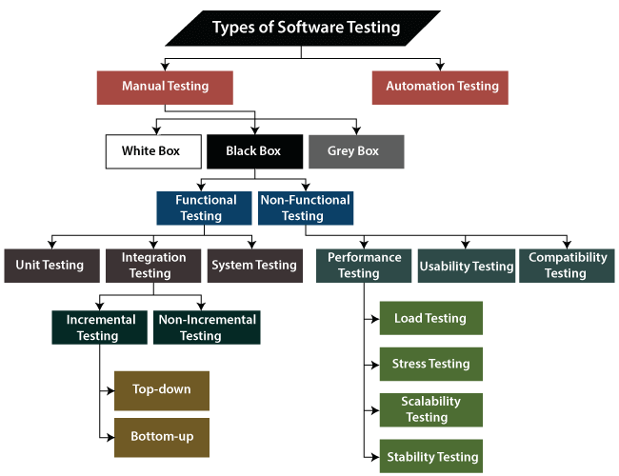

Types :

1)Functional Testing:-

a)Unit Testing-

It involves verification of individual components or units of source code.

Integrating Testing:-

It involves testing of combined modules of source code.

System Testing:-

Testing complete integrated system with specified requirements .

**Acceptance Testing:-**

It is conducted to determine if the requirements of specification are met.

a. Alpha Testing: Ensuring bug free functionality.

b. Beta Testing: It involves releasing Software to limited number of real users. (User Acceptance testing).

**Sanity Testing:**

Checking the main functionalities of application without going any deeper to determine if further testing can proceed or not.

**Smoke Testing:**

S/w testing process that determines whether deployed s/w build is stable or not.

**Exploraitry testing:-**Testing the software when application is ready but, you don’t have document.

**Monkey Testing:-**Testing Randomly without knowledge of requirement or Testing the application and trying to break without complete knowledge

**Adhoc Testing:-**Testing the full application and trying to break the application with complete system knowledge

**Black Box Testing**:- Testing External behaviour of system

**White Box** :-Testing Internal functionalities of system

**B+W=Grey**=>Testing both internal functionality and external behaviour of system

**Regression Testing:-**

It is testing functional or non-functional properties to make sure that old functionality is working fine whenever new functionality is released.

or

Regression Testing is rerunning functional and non-functional tests to ensure that previously developed and tested software still performs as expected after change.